|  |
| --- |
| Project on Global Warming |
| [Type the document subtitle] |
| Name-Ritesh Tiwari  Roll no- 16G201707C  Course-CCA |
|  |

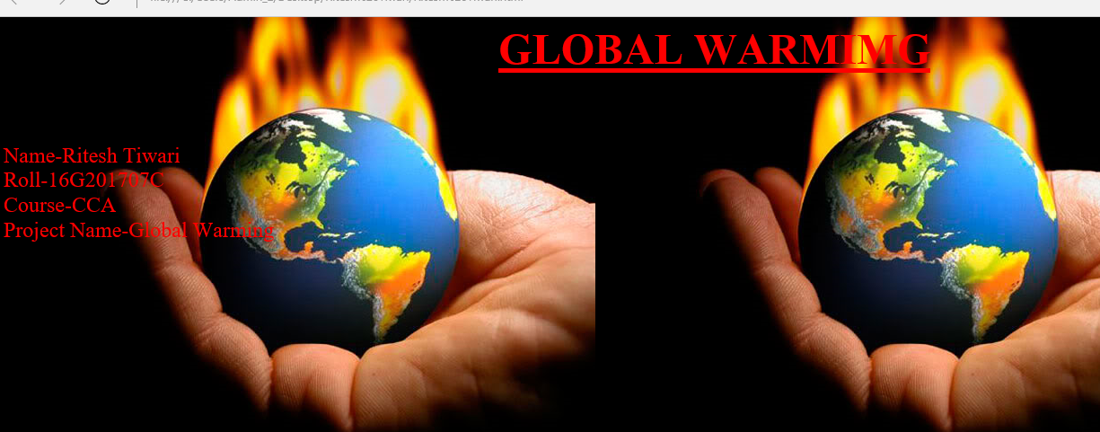

<html>

<head>

<title>Global Warming Project</title>

</head>

<body background ="C:\Users\Admin_2\Desktop\Global Warming\Global-Warming-Climate-Change.jpg" >

<center><h1><b><font color="red" size="10"><u>GLOBAL WARMIMG</u></b></h1></center><br>

<font color="red" size="5">Name-Ritesh Tiwari<br>Roll-16G201707C<br>Course-CCA<br>Project Name-Global Warming

</body></html>

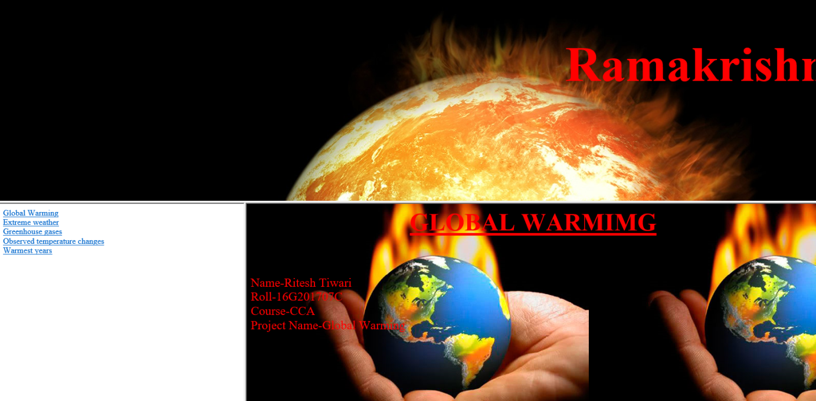

<html>

<frameset rows="50%,*">

<frame src="C:\Users\Admin_2\Desktop\Ritesh Tiwari\rkmscc.html">

<frameset cols="30%,*">

<frame src="C:\Users\Admin_2\Desktop\Ritesh Tiwari\hyperlink.html">

<frame src="C:\Users\Admin_2\Desktop\Ritesh Tiwari\Ritesh Tiwari.html">

</frameset>

</frameset>

</html>

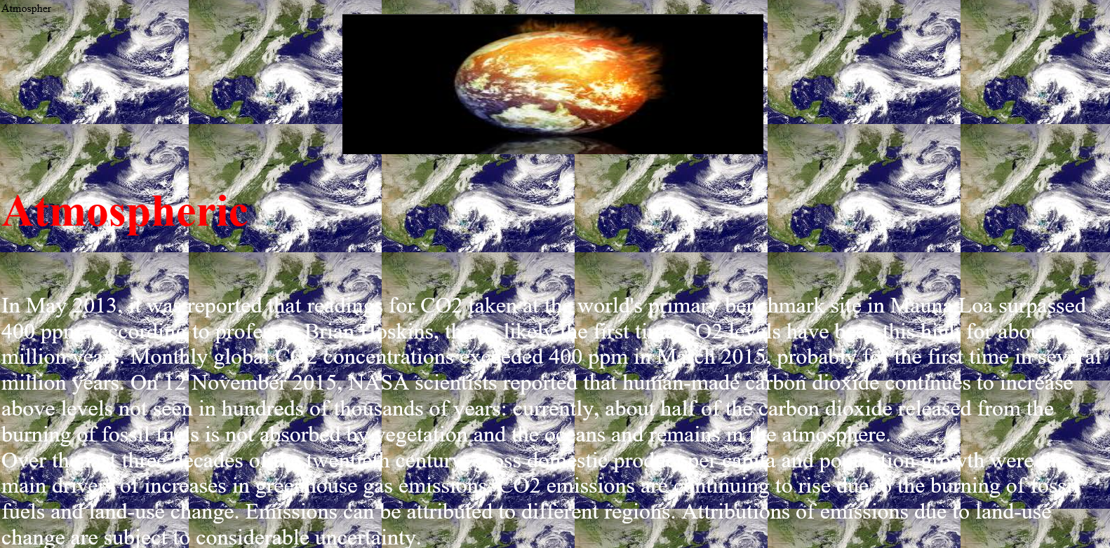

<html>

<head>

<titlt>Atmospher</title></head>

<body background="C:\Users\Admin_2\Desktop\Global Warming\images (28).jpg">

<center><img src="C:\Users\Admin_2\Desktop\Global Warming\images (6).jpg" width="600" height="200"></center>

<font color="red" size="6"><h1><b>Atmospheric </b></h1><br>

<font color ="white" size="6">In May 2013, it was reported that readings for CO2 taken at the world's primary benchmark site in Mauna Loa surpassed 400 ppm. According to professor Brian Hoskins, this is likely the first time CO2 levels have been this high for about 4.5 million years. Monthly global CO2 concentrations exceeded 400 ppm in March 2015, probably for the first time in several million years. On 12 November 2015, NASA scientists reported that human-made carbon dioxide continues to increase above levels not seen in hundreds of thousands of years: currently, about half of the carbon dioxide released from the burning of fossil fuels is not absorbed by vegetation and the oceans and remains in the atmosphere.<br>Over the last three decades of the twentieth century, gross domestic product per capita and population growth were the main drivers of increases in greenhouse gas emissions. CO2 emissions are continuing to rise due to the burning of fossil fuels and land-use change. Emissions can be attributed to different regions. Attributions of emissions due to land-use change are subject to considerable uncertainty.<br>Emissions scenarios, estimates of changes in future emission levels of greenhouse gases, have been projected that depend upon uncertain economic, sociological, technological, and natural developments. In most scenarios, emissions continue to rise over the century, while in a few, emissions are reduced. Fossil fuel reserves are abundant, and will not limit carbon emissions in the 21st century. Emission scenarios, combined with modelling of the carbon cycle, have been used to produce estimates of how atmospheric concentrations of greenhouse gases might change in the future. Using the six IPCC SRES "marker" scenarios, models suggest that by the year 2100, the atmospheric concentration of CO2 could range between 541 and 970 ppm. This is 90–250% above the concentration in the year 1750.<br>The popular media and the public often confuse global warming with ozone depletion, i.e., the destruction of stratospheric ozone (e.g., the ozone layer) by chlorofluorocarbons. Although there are a few areas of linkage, the relationship between the two is not strong. Reduced stratospheric ozone has had a slight cooling influence on surface temperatures, while increased tropospheric ozone has had a somewhat larger warming effect.<br>

<center><img src="C:\Users\Admin_2\Desktop\Global Warming\images (27).jpg" width="600" height="200"></center><br>

<font color="red" size="6"><h1><b>Extreme weather</b></h1><br><br>

<font color="white" size="6">Main articles: Extreme weather and Physical impacts of climate change § Extreme events<br>Changes in regional climate are expected to include greater warming over land, with most warming at high northern latitudes, and least warming over the Southern Ocean and parts of the North Atlantic Ocean.<br>Future changes in precipitation are expected to follow existing trends, with reduced precipitation over subtropical land areas, and increased precipitation at subpolar latitudes and some equatorial regions.[158] Projections suggest a probable increase in the frequency and severity of some extreme weather events, such as heat waves.<br><br>

<font color="red" size="6"><h1><b>Ecological systems</b></h1><br><br>

<font color="white" size="6">

In terrestrial ecosystems, the earlier timing of spring events, as well as poleward and upward shifts in plant and animal ranges, have been linked with high confidence to recent warming. Future climate change is expected to affect particular ecosystems, including tundra, mangroves, and coral reefs. It is expected that most ecosystems will be affected by higher atmospheric CO2 levels, combined with higher global temperatures. Overall, it is expected that climate change will result in the extinction of many species and reduced diversity of ecosystems.<br>Increases in atmospheric CO2 concentrations have led to an increase in ocean acidity. Dissolved CO2 increases ocean acidity, measured by lower pH values.[173] Between 1750 and 2000, surface-ocean pH has decreased by ˜0.1, from ˜8.2 to ˜8.1. Surface-ocean pH has probably not been below ˜8.1 during the past 2 million years. Projections suggest that surface-ocean pH could decrease by an additional 0.3–0.4 units by 2100. Future ocean acidification could threaten coral reefs, fisheries, protected species, and other natural resources of value to society.

</body>

</html>

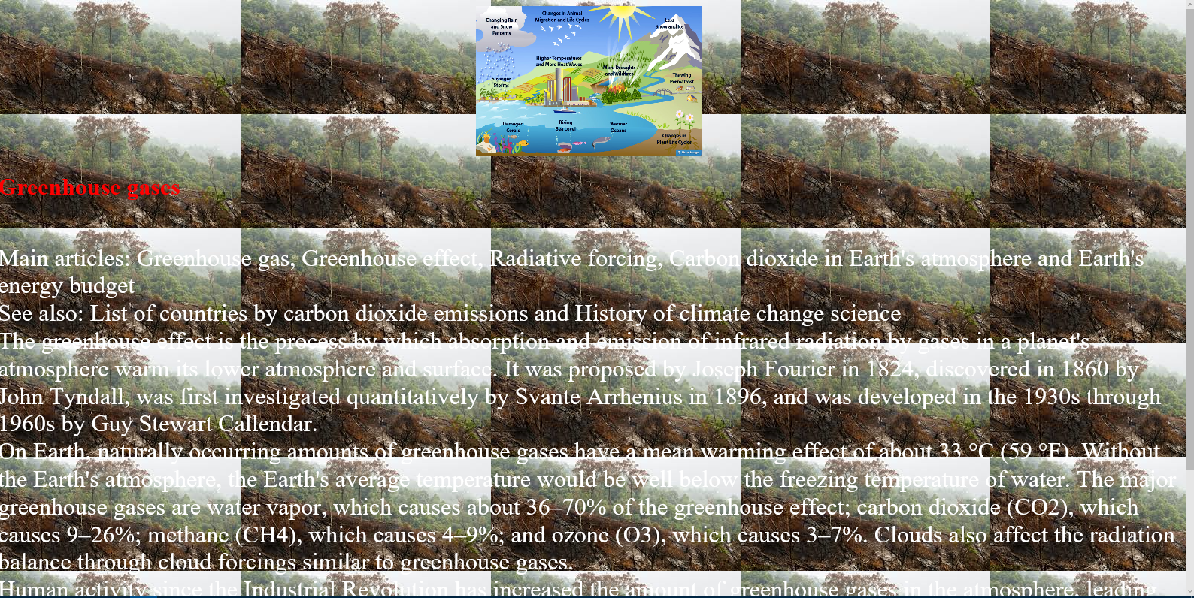

<html>

<head>

<title>Greenhouse gases</title>

</head>

<body background="C:\Users\Admin_2\Desktop\Global Warming\download (4).jpg">

<center><img src="C:\Users\Admin_2\Desktop\Global Warming\10-other-climate-effects-EPA.png" width="300" height="200"><br></center>

<h1><font color="red">Greenhouse gases</h1><br><br>

<font color="white" size="6">Main articles: Greenhouse gas, Greenhouse effect, Radiative forcing, Carbon dioxide in Earth's atmosphere and Earth's energy budget<br>See also: List of countries by carbon dioxide emissions and History of climate change science<br>The greenhouse effect is the process by which absorption and emission of infrared radiation by gases in a planet's atmosphere warm its lower atmosphere and surface. It was proposed by Joseph Fourier in 1824, discovered in 1860 by John Tyndall, was first investigated quantitatively by Svante Arrhenius in 1896, and was developed in the 1930s through 1960s by Guy Stewart Callendar.<br>On Earth, naturally occurring amounts of greenhouse gases have a mean warming effect of about 33 °C (59 °F). Without the Earth's atmosphere, the Earth's average temperature would be well below the freezing temperature of water. The major greenhouse gases are water vapor, which causes about 36–70% of the greenhouse effect; carbon dioxide (CO2), which causes 9–26%; methane (CH4), which causes 4–9%; and ozone (O3), which causes 3–7%. Clouds also affect the radiation balance through cloud forcings similar to greenhouse gases.<br>Human activity since the Industrial Revolution has increased the amount of greenhouse gases in the atmosphere, leading to increased radiative forcing from CO2, methane, tropospheric ozone, CFCs and nitrous oxide. According to work published in 2007, the concentrations of CO2 and methane have increased by 36% and 148% respectively since 1750.[74] These levels are much higher than at any time during the last 800,000 years, the period for which reliable data has been extracted from ice cores.Less direct geological evidence indicates that CO2 values higher than this were last seen about 20 million years ago.<br>

</body>

</html>

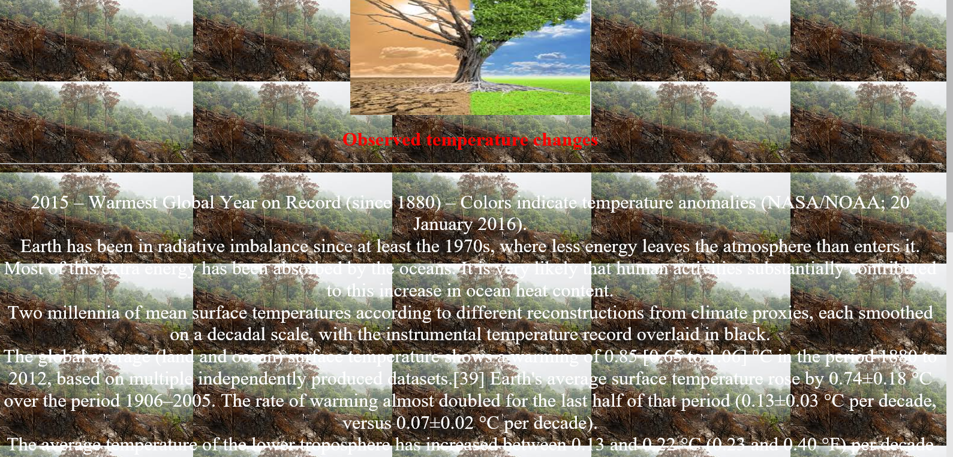

<html>

<head>

<title>Observed temperature changes</title>

</head>

<body background="C:\Users\Admin_2\Desktop\Global Warming\download (4).jpg">

<center><img src="C:\Users\Admin_2\Desktop\Global Warming\download (2).jpg" width="400" height="200"><br>

<center><h1><font color="red" size="6">Observed temperature changes</h1><hr><br>

<font color="white" size="6">

2015 – Warmest Global Year on Record (since 1880) – Colors indicate temperature anomalies (NASA/NOAA; 20 January 2016).<br>Earth has been in radiative imbalance since at least the 1970s, where less energy leaves the atmosphere than enters it. Most of this extra energy has been absorbed by the oceans. It is very likely that human activities substantially contributed to this increase in ocean heat content.<br>Two millennia of mean surface temperatures according to different reconstructions from climate proxies, each smoothed on a decadal scale, with the instrumental temperature record overlaid in black.<br>The global average (land and ocean) surface temperature shows a warming of 0.85 [0.65 to 1.06] °C in the period 1880 to 2012, based on multiple independently produced datasets.[39] Earth's average surface temperature rose by 0.74±0.18 °C over the period 1906–2005. The rate of warming almost doubled for the last half of that period (0.13±0.03 °C per decade, versus 0.07±0.02 °C per decade).<br>The average temperature of the lower troposphere has increased between 0.13 and 0.22 °C (0.23 and 0.40 °F) per decade since 1979, according to satellite temperature measurements. Climate proxies show the temperature to have been relatively stable over the one or two thousand years before 1850, with regionally varying fluctuations such as the Medieval Warm Period and the Little Ice Age.<br><br><br></center>

<font color="black"><b>Trends</b><br>

<font color="white"><center>Temperature changes vary over the globe. Since 1979, land temperatures have increased about twice as fast as ocean temperatures (0.25 °C per decade against 0.13 °C per decade). Ocean temperatures increase more slowly than land temperatures because of the larger effective heat capacity of the oceans and because the ocean loses more heat by evaporation. Since the beginning of industrialisation the temperature difference between the hemispheres has increased due to melting of sea ice and snow in the North. Average arctic temperatures have been increasing at almost twice the rate of the rest of the world in the past 100 years; however arctic temperatures are also highly variable. Although more greenhouse gases are emitted in the Northern than Southern Hemisphere this does not contribute to the difference in warming because the major greenhouse gases persist long enough to mix between hemispheres.<br>

The thermal inertia of the oceans and slow responses of other indirect effects mean that climate can take centuries or longer to adjust to changes in forcing. Climate commitment studies indicate that even if greenhouse gases were stabilized at year 2000 levels, a further warming of about 0.5 °C (0.9 °F) would still occur.<br>

Global temperature is subject to short-term fluctuations that overlay long-term trends and can temporarily mask them. The relative stability in surface temperature from 2002 to 2009, which has been dubbed the global warming hiatus by the media and some scientists, is consistent with such an episode. 2015 updates to account for differing methods of measuring ocean surface temperature measurements show a positive trend over the recent decade.<br></center>

</body>

</html>

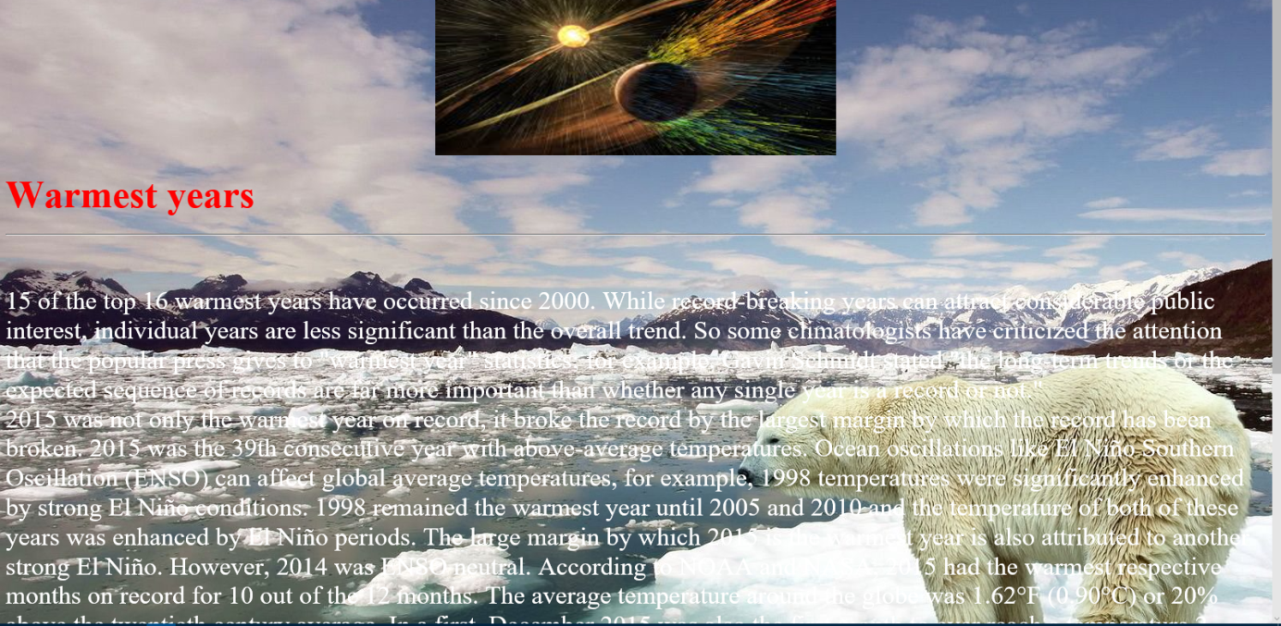

<html>

<head>

<title>Warmest years</title>

</head>

<body background="C:\Users\Admin_2\Desktop\Global Warming\8845010-stop-global-warming.jpg">

<center><img src="C:\Users\Admin_2\Desktop\Global Warming\images (25).jpg" width="500" height="200"><br></center>

<h1><b><font color="red" size="10">Warmest years</b></h1><hr><br>

<font color="white" size="6">15 of the top 16 warmest years have occurred since 2000. While record-breaking years can attract considerable public interest, individual years are less significant than the overall trend. So some climatologists have criticized the attention that the popular press gives to "warmest year" statistics; for example, Gavin Schmidt stated "the long-term trends or the expected sequence of records are far more important than whether any single year is a record or not."<br>2015 was not only the warmest year on record, it broke the record by the largest margin by which the record has been broken. 2015 was the 39th consecutive year with above-average temperatures. Ocean oscillations like El Niño Southern Oscillation (ENSO) can affect global average temperatures, for example, 1998 temperatures were significantly enhanced by strong El Niño conditions. 1998 remained the warmest year until 2005 and 2010 and the temperature of both of these years was enhanced by El Niño periods. The large margin by which 2015 is the warmest year is also attributed to another strong El Niño. However, 2014 was ENSO neutral. According to NOAA and NASA, 2015 had the warmest respective months on record for 10 out of the 12 months. The average temperature around the globe was 1.62°F (0.90°C) or 20% above the twentieth century average. In a first, December 2015 was also the first month to ever reach a temperature 2 degrees Fahrenheit above normal for the planet.<br>Initial causes of temperature changes (external forcings)<br>Main article: Attribution of recent climate change<br>refer to caption and adjacent text<br>Greenhouse effect schematic showing energy flows between space, the atmosphere, and Earth's surface. Energy exchanges are expressed in watts per square meter (W/m2).<br>This graph, known as the Keeling Curve, documents the increase of atmospheric carbon dioxide concentrations from 1958–2015. Monthly CO2 measurements display seasonal oscillations in an upward trend; each year's maximum occurs during the Northern Hemisphere's late spring, and declines during its growing season as plants remove some atmospheric CO2.

The climate system can warm or cool in response to changes in external forcings.These are "external" to the climate system but not necessarily external to Earth. Examples of external forcings include changes in atmospheric composition (e.g., increased concentrations of greenhouse gases), solar luminosity, volcanic eruptions, and variations in Earth's orbit around the Sun.

</body>

</html>

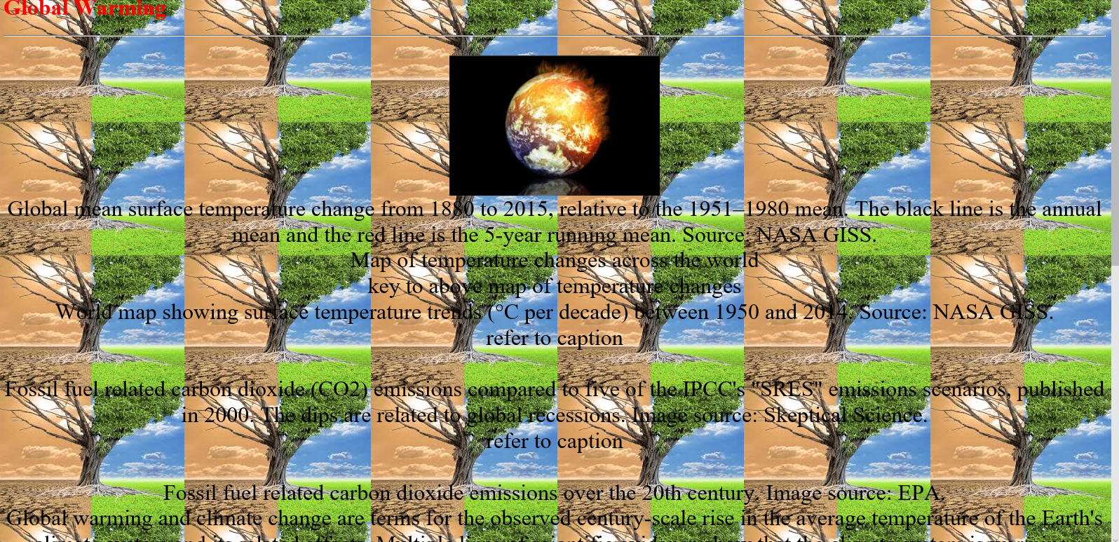

<html>

<head>

<title>Global Warming</title>

</head>

<body background="C:\Users\Admin_2\Desktop\Global Warming\download (2).jpg">

<h1><font color="red">Global Warming</h1><hr><br>

<center><img src="C:\Users\Admin_2\Desktop\Global Warming\images (6).jpg" width="300" height="200"><br></center>

<center><font color="black" size="6">Global mean surface temperature change from 1880 to 2015, relative to the 1951–1980 mean. The black line is the annual mean and the red line is the 5-year running mean. Source: NASA GISS.<br>Map of temperature changes across the world<br>key to above map of temperature changes<br>World map showing surface temperature trends (°C per decade) between 1950 and 2014. Source: NASA GISS.<br>refer to caption<br><br>Fossil fuel related carbon dioxide (CO2) emissions compared to five of the IPCC's "SRES" emissions scenarios, published in 2000. The dips are related to global recessions. Image source: Skeptical Science.<br>refer to caption<br><br>Fossil fuel related carbon dioxide emissions over the 20th century. Image source: EPA.<br>Global warming and climate change are terms for the observed century-scale rise in the average temperature of the Earth's climate system and its related effects. Multiple lines of scientific evidence show that the climate system is warming. Although the increase of near-surface atmospheric temperature is the measure of global warming often reported in the popular press, most of the additional energy stored in the climate system since 1970 has gone into ocean warming. The remainder has melted ice and warmed the continents and atmosphere.[a] Many of the observed changes since the 1950s are unprecedented over tens to thousands of years. On 12 November 2015, NASA scientists reported that human-made carbon dioxide (CO2) continues to increase above levels not seen in hundreds of thousands of years: currently, about half of the carbon dioxide released from the burning of fossil fuels is not absorbed by vegetation and the oceans and remains in the atmosphere.<br><br>Scientific understanding of global warming is increasing. The Intergovernmental Panel on Climate Change (IPCC) reported in 2014 that scientists were more than 95% certain that global warming is mostly being caused by increasing concentrations of greenhouse gases (GHG) and other human (anthropogenic) activities. Climate model projections summarized in the report indicated that during the 21st century the global surface temperature is likely to rise a further 0.3 to 1.7 °C (0.5 to 3.1 °F) for their lowest emissions scenario using stringent mitigation and 2.6 to 4.8 °C (4.7 to 8.6 °F) for their highest.<br>These findings have been recognized by the national science academies of the major industrialized nations[b] and are not disputed by any scientific body of national or international standing.<br><br>Public reactions to global warming and general fears of its effects are also steadily on the rise, with a global 2015 Pew Research Center report showing a median of 54% who consider it "a very serious problem". There are, however, significant regional differences. Notably, Americans and Chinese, whose economies are responsible for the greatest annual CO2 emissions, are among the least concerned.

</body>

</html>